

**ClickView Online**

**Morley Senior High School 19-43 Bramwell Road, Noranda, WA 6062**

**Library Editor**

**IT Team**

**Contents**

**1.** **Open your web browser and go to:** 2

1.1 https://online.clickview.com.au 2

 2

1.2 Click on “Sign In” 2

**2. Enter your student email address and Click “Next”** 2

**3.0 Select Morley Senior High School from the drop-down arrow.** 2

**See below:** 2

**4.0 Click on Proceed** 2

4.1 Type your **userid** and **password**: the same password which you use for logging on your desktop. See below: 2

4.2 On your first sign in you will be asked to verify your email address. 2

4.3 Enter your email address. **For eg** ***........@student.education.wa.edu.au*** 3

**5.0 Open “Outlook” and click on verify my email address. See below:** 3

**6.0 After completing all the above steps, click on “return to Dashboard”** 3

**7.0 Conclusion** 3

7.1 If you encounter any issue, please inform your teacher 3

**ClickView Online**

# **Open your web browser and go to:**

## 1.1 <https://online.clickview.com.au>

## 

## 1.2 Click on “**Sign In**”

# **2. Enter your student email address and Click “Next”**



# **3.0 Select Morley Senior High School from the drop-down arrow.**

# **See below:**

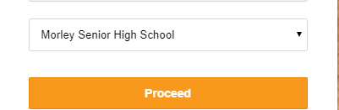

# **4.0 Click on Proceed**

## 4.1 Type your **userid** (**NOT EMAIL ADDRESS**) and **password**: the same password which you use for logging on your desktop. See below:

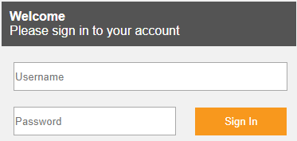

## 4.2 On your first sign in you will be asked to verify your email address.



cid:image001.png@01D5FD2D.4FFE5000

## 4.3 Enter your email address. **For eg** ***........@student.education.wa.edu.au***

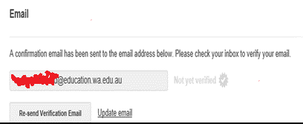

# **5.0 Open “Outlook” and click on verify my email address. See below:**

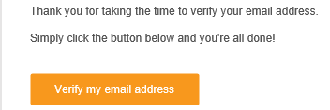

# **6.0 After completing all the above steps, click on “return to Dashboard”**

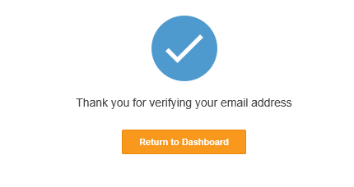

# **7.0 Conclusion**

## 7.1 If you encounter any issue, please inform your teacher